**😊 Lab 2 (Python) - Develop Solutions Using Amazon S3**

1. First download the zip file for Lab2, unzip it and open it in VS Code.
2. Below you can see the code, go to the config.ini file, here you need to change the bucket name and object name. For the object name, you need to provide the path of the folder.

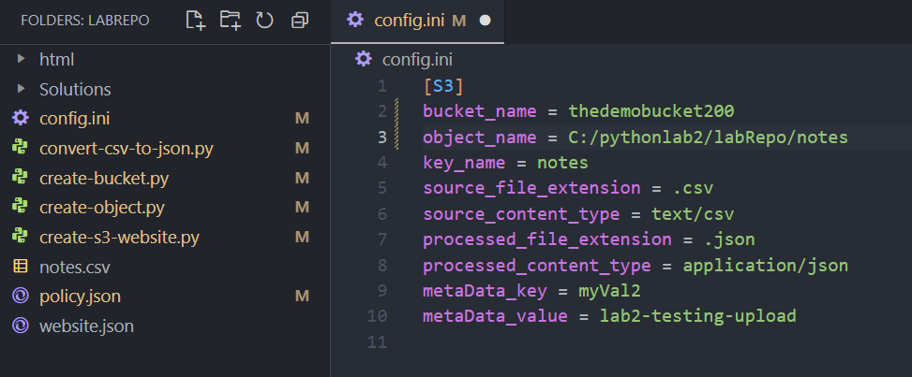

1. Then go to create bucket file and here you must change the path for read config. Then use the command below to create a bucket using the terminal in VS Code.

**python create-bucket.py**

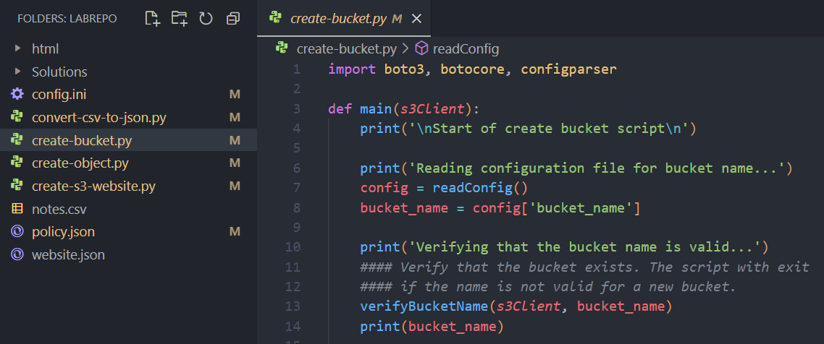

1. You must do the same thing to create-object and convert CSV to JSON file. Then just run the commands below to execute them.

**python create-object.py**

**python convert-csv-to-json.py**

1. Now we are going to configure static website hosting on an Amazon S3 bucket which we just created. So, in your terminal, you are going to run the below commands.
2. Open the terminal in VS Code and use the s3api service to create a variable that contains your bucket name using the command below.

**$mybucket='YOUR_BUCKET_NAME'**

1. Update the public-access-block permissions on the bucket.

**aws s3api put-public-access-block --bucket $mybucket --public-access-block-configuration "BlockPublicPolicy=false,RestrictPublicBuckets=false"**

1. Run the command below to sync the files in the html folder with your bucket including the index.html and error.html files along with any assets used in those webpages:

**aws s3 sync C:/code/html/. s3://$mybucket/**

1. Run the following command to enable the Amazon S3 website hosting:

**aws s3api put-bucket-website --bucket $mybucket --website-configuration** **file://C:/code/website.json**

1. Run the following command to enable the Amazon S3 website hosting:

**aws s3api put-bucket-website --bucket $mybucket --website-configuration** **file://C:/code/website.json**

1. Run the below command to generate the URL, so that you can access your Website.

**$myRegion = "ap-south-1" # Replace with your actual region**

**$mybucket = "YOUR_BUCKET_NAME"**

**"`nYou can now access the website at:`nhttp://$mybucket.s3-website.$myRegion.amazonaws.com`n`n"**